**Pozyx Setup Notes**

## Step 1: Place 4x Anchors in desired locations

* NOTE: 4x Anchors are required for 3-D positioning
* Position / locate Anchors in a space to define a cubic volume
* Set Anchor heights (‘z’ position) alternating high / low (or diagonally opposite as shown below)

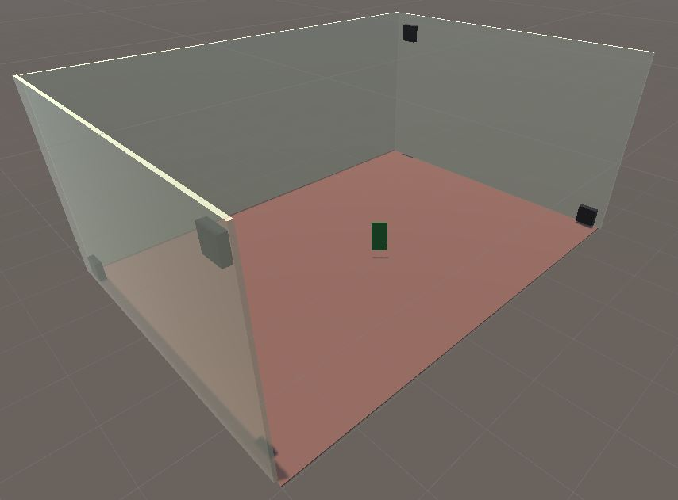

Tag

Anchors

Anchors

* One Pozyx device must be connected to your computer / laptop via USB cable for the system to work. For ease of use, connect an Anchor and define it as the point of origin
  + Point of origin anchor has position (0, 0, z)
    - ‘z’ value is set to height of anchor (height is always measured from ground / floor)
  + Note: an alternative is to utilise a spare Tag as a surrogate Anchor / Master controller. Simply remove the T/A Jumper from the tag’s board and connect the device to your computer / laptop (via USB cable).

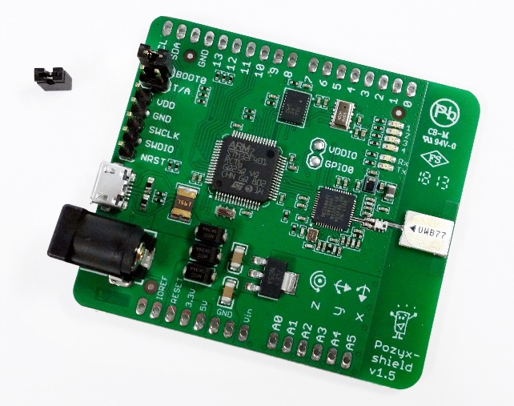

T/A Jumper removed:

(Tag becomes Anchor)

* + - Device will power on and automatically communicate with other remote Pozyx devices (Anchors and Tag(s)).
      * Plug-and-play option – no file changes are required!
    - (Optional): Utilise as a true Anchor. Measure “new” anchor’s position relative to origin and add information to ‘anchors.txt’ file.
      * > 4 anchors = increased accuracy in 3-D
* Measure / record each remaining anchor’s position (x, y, z) relative to the point of origin
  + NOTES:
    - ‘x, y’ values are set relative to point of origin
    - ‘z’ value is set to height of anchor (height is always measured from ground / floor)
    - Take measurement from Centre-Top of Anchor
      * where UWB chip is located on board
    - Assign coordinate axes using right hand grip rule
    - Some positions can be negative
* Connect remaining 3x Anchors (remotes) to power outlets and switch on.

## Step 2: Required Downloads / Installations

* (Optional) Install Unity3d (2018.2.18f1 or later)
  + <https://unity3d.com/>
* Install ST’s virtual COM driver:
  + Google Drive link:
    - <https://drive.google.com/file/d/1f2j_OHPpYvawyQaeYCNG52dGGsCwoMNI/view?usp=sharing>
  + NOTE: This driver is required, even for Windows 10.
* Download the Pozyx Positioning Application:
  + Google Drive link:
    - <https://drive.google.com/file/d/15kPOfWOS7a3x8w7s4qwi18ec-KUv8-FO/view?usp=sharing>
  + NOTE: this application may be used for either:
    - Single Tag positioning / orientation
    - Multiple Tag positioning / orientation
  + See Step 4 (below) for additional information

## Step 3: Pozyx Tag(s)

* Connect one (or more) Pozyx Tags to a remote power source (ie. 9-volt Battery or USB-port / electrical outlet)
* OPTIONS:
  + 9v to 2.1mm DC plug cable (Figure 3a)
    - NOTE: 2.1mm to 2.5mm DC plug adapter required
  + 9v to micro USB (phone charger unit) (Figure 3b)

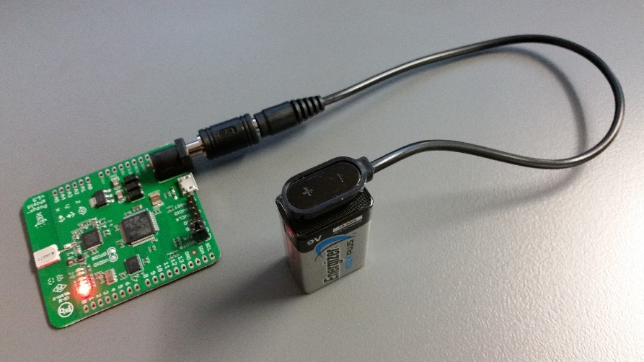

Figure 3a: Pozyx Tag connected to 9v battery via DC plug cable and adapter

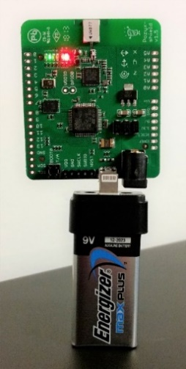

Figure 3b: Pozyx Tag connected to micro USB (phone charger unit)

## Step 4: Run Pozyx Positioning Application

* Download pozyxPositioning.zip and unzip contents to a user-designated folder on PC
  + Google Drive link:
    - <https://drive.google.com/file/d/15kPOfWOS7a3x8w7s4qwi18ec-KUv8-FO/view?usp=sharing>
    - Ignore any warnings
  + Contents of file:
    - pozyxPositioning.exe - application to run Pozyx (single) tag positioning
    - tagIDs.txt - list of available tags (Do not modify)
    - anchors.txt - list of anchor IDs and user-defined co-ordinates
    - ReadMe.txt - information on how to setup / run the application
* Open ‘anchors.txt’ file in Notepad or any text file editor
  + Edit / update anchor (x, y, z) co-ordinates for each anchor (as required)
    - Using measured values from Step 1
    - NOTE: this file only needs to be modified / updated if the Pozyx Anchors’ positions are changed

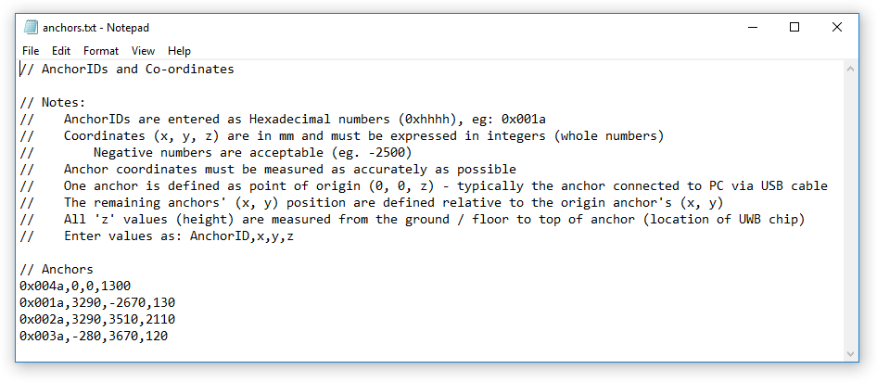

Figure 4: Contents of ‘anchors.txt’ file showing anchor IDs and user-definable coordinates

* Run pozyxPositioning.exe application file (double-click)
  + NOTES:
    - ensure Pozyx Anchors and Tag are connected and powered up prior
    - for first time execution, ignore any Windows security warnings

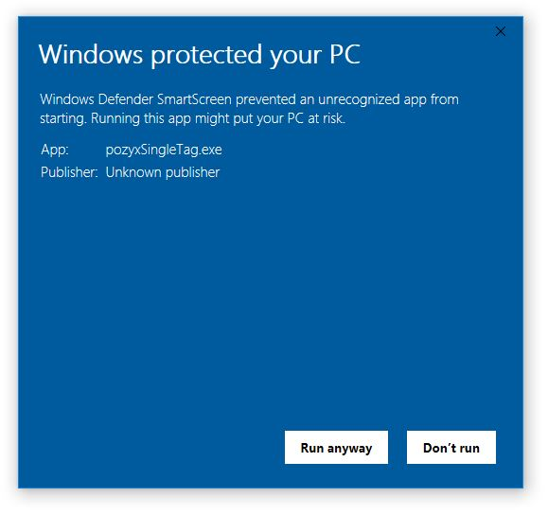

Figure 5: Ignore Windows Defender warnings: click ‘Run anyway’

* + - ‘tagIDs.txt’ and ‘anchors.txt’ files must be kept in same directory as pozyxPositioning.exe
  + application will execute and a console window will be displayed, showing a user menu

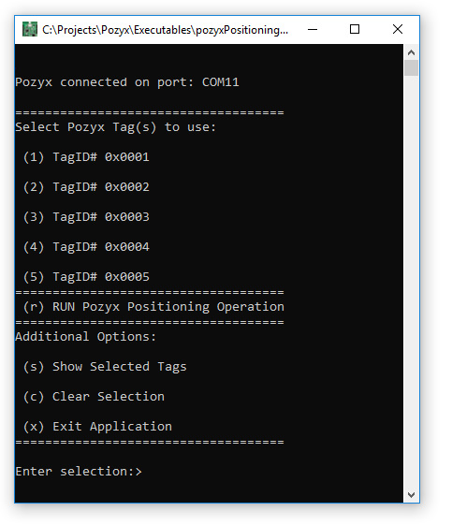

Figure 6: Pozyx Tag selection menu is presented to user

* + select the appropriate Pozyx Tag(s) from the menu
    - Single Tag Operation:
      * Example:
        + Press ‘1’, then ‘ENTER’ to select Pozyx Tag #0x0001
        + Press ‘r’, then ‘ENTER’ to start positioning operation
    - Multiple Tag Operation:
      * Example:
        + Press ‘2’, then ‘ENTER’ to select Pozyx Tag# 0x0002
        + Press ‘3’, then ‘ENTER’ to select Pozyx Tag# 0x0003
        + Press ‘r’, then ‘ENTER’ to start positioning operation
  + Pozyx Tag will commence positioning

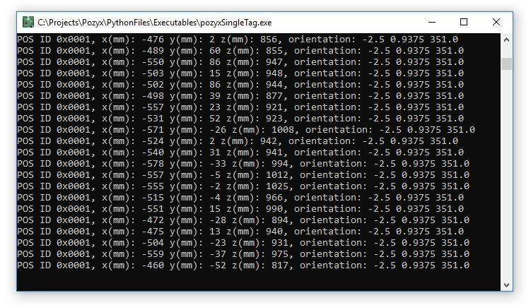

Figure 7: Sample output of Pozyx positioning system during execution

* + NOTES:
    - this application feeds position (x, y, z) and orientation (p, r, y) into Unity via OSC Protocol on:
      * IP Address: 127.0.0.1 [local host]
      * Port: 8888
    - this application MUST be run prior to attempting to run the Unity Project
    - anchor co-ordinates (x, y, z) are stored in ‘anchors.txt’ file and should be modified only if anchor(s) are moved into a new location / position (Figure 4)
    - Tag IDs (hexadecimal values) are stored in ‘tagIDs.txt’ file and should not be modified
      * corresponding Tag ID labels are stuck on to rear of Tags (Figure 8)
      * corresponding Anchor ID labels are stuck on to top of Anchors

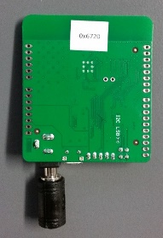

Figure 8: Pozyx Tag ID

## Step 6a: (Optional) Run Unity-Project: PozyxUnity - SingleTag

* Download and unzip the Unity project ‘PozyxUnity – SingleTag’ to a user-designated folder:
  + Google Drive link:
    - <https://drive.google.com/open?id=1MdhZ8oSKFlxqlxmXYsQcvGXuPbf__9Jn>
    - Ignore any warnings

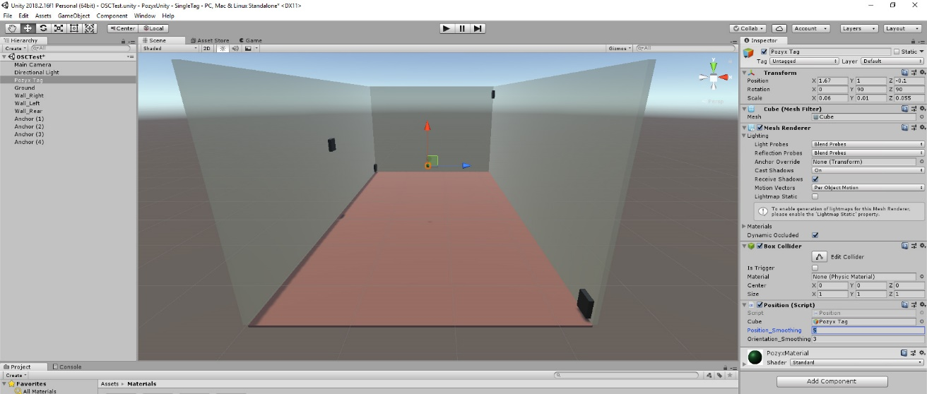

Figure 9: Unity Project interface

* Open Unity project ‘PozyxUnity – SingleTag’ in Unity3D application (see Step 1)
  + (Optional) Select ‘Pozyx Tag’ game object (left menu) and enter desired position and orientation smoothing values (right menu: Position (Script))

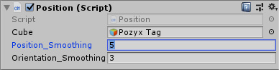

Figure 10: PozyxTag (GameObejct) – Smoothing Settings

* + - NOTES:
      * Smoothing values can be individually set for both position and / or orientation motion to reduce jerkiness
      * Values are set from:
        + 1 = No smoothing
        + 2 or greater = increased smoothing
      * Higher smoothing values increases motion latency / delay
* While ‘pozyxPositioning.exe’ is running (see Step 5), press ‘PLAY’ on Unity interface
  + NOTES:
    - ‘pozyxPositioning.exe’ must be running prior to playing the Unity project
      * Data is fed from Pozyx, into the application and then streamed into Unity via Open Sound Control (OSC) protocol
    - STOP playing Unity project **before** stopping / closing Python script
      * To avoid a continuous loop / Unity appears to hang
      * If this does occur, simply re-run python script then STOP Unity project

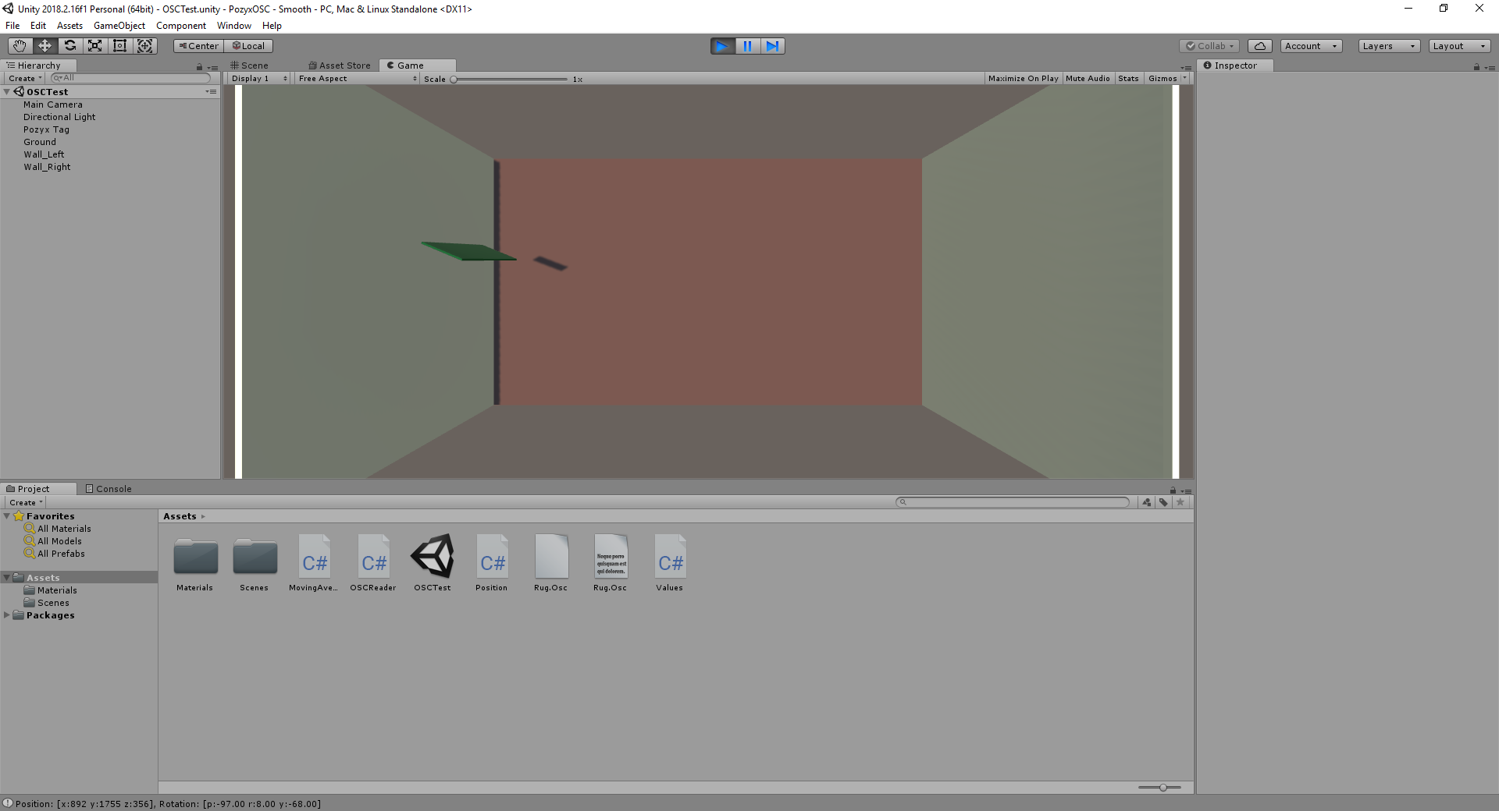

Figure 11: Running ‘PozyxUnity – SingleTag’ Unity Project

## Step 6b: (Optional) Run Unity-Project: PozyxUnity – MultiTag

* Download and unzip the Unity project ‘PozyxUnity – MultiTag’ to a user-designated folder:
  + Google Drive link:
    - Ignore any warnings



Figure 9: Unity Project interface

* Open Unity project ‘PozyxUnity – MultiTag’ in Unity3D application (see Step 1)
  + Activate / De-activate desired tag(s) to use
    - Select appropriate ‘Pozyx Tag’ game object (left menu)
    - Click ‘GameObject’ from top menu
    - Click ‘Toggle Active State’ from drop down menu

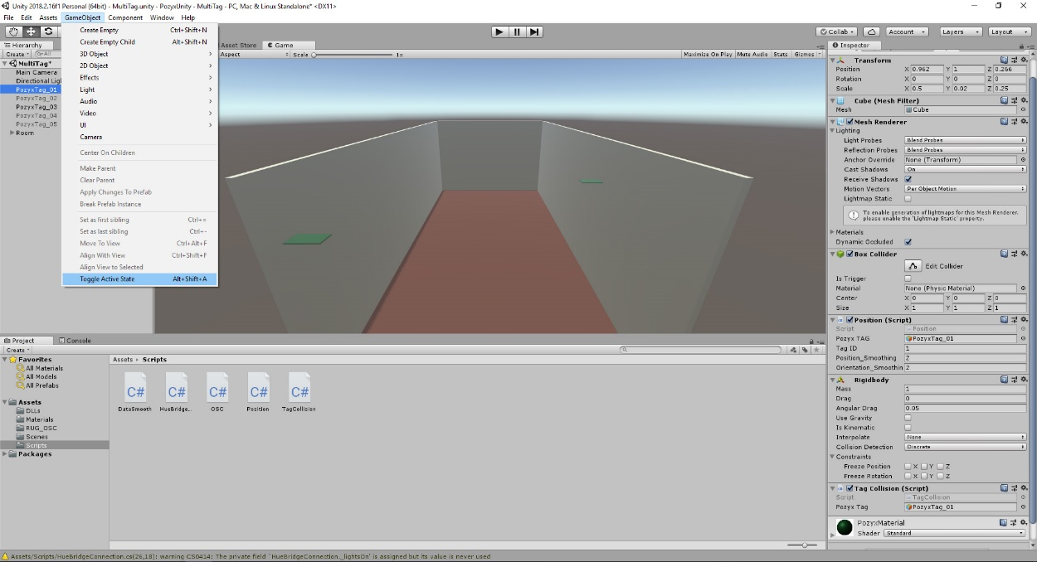

Figure 10: PozyxTag (GameObejct) toggling Active / Inactive

* + - NOTES:
      * Ensure that only Tags in use are set to active

Eg: if using Tag 1 and Tag 3, these should be active, with the remaining Tag game objects inactive

* + - * Failure to do so correctly may result in Unity freezing / errors
  + Smoothing values can be individually set for both position and / or orientation motion to reduce jerkiness
    - Values are set from:
      * 1 = No smoothing
      * 2 or greater = increased smoothing
      * Higher smoothing values increases motion latency / delay
* While ‘pozyxPositioning.exe’ is running (see Step 5), press ‘PLAY’ on Unity interface
  + NOTES:
    - ‘pozyxPositioning.exe’ must be running prior to playing the Unity project and applicable tags selected
      * Tags have been named to match
        + eg: Pozyx Tag 0x0001 is PozyxTag_01 in Unity
      * Data is fed from Pozyx, into the application and then streamed into Unity via Open Sound Control (OSC) protocol
    - STOP playing Unity project **before** stopping / closing Python script
      * To avoid a continuous loop / Unity appears to hang
      * If this does occur, simply re-run python script then STOP Unity project



Figure 11: Running ‘PozyxUnity – SingleTag’ Unity Project

## Additional Notes

* Accuracy of the Poxyx Tag(s) may diminish as battery life deteriorates

## Source Code

* All source code (Python) files are available on Google Drive:
  + Link: https://drive.google.com/drive/folders/1fSZsK0Kfqo2mBGzqIN_doj5CTJE9IFVQ?usp=sharing
* Original Pozyx source code (Python) files are available on Google Drive:
  + Link: <https://drive.google.com/drive/folders/140HnsQ3DgbZL-wxljcpPInDfQ488XVY4?usp=sharing>
  + Github: <https://github.com/pozyxLabs/Pozyx-Python-library>
* Install Python 3.7 (or later)
  + <https://www.python.org/downloads/windows/>
  + Install 32-bit or 64-bit (as required)
  + NOTES:
    - make sure “Add Python 3.X to PATH” is checked / activated

(refer to Figure 1)

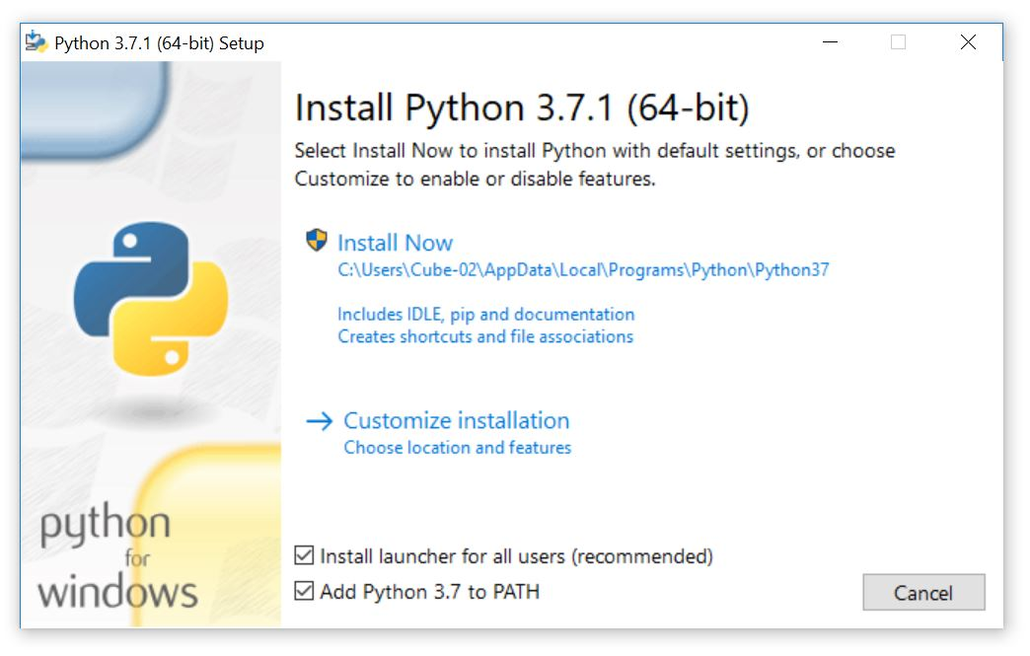

Figure 1: Add Python to PATH

* + - (optional) Disable PATH length limit

(refer to image)

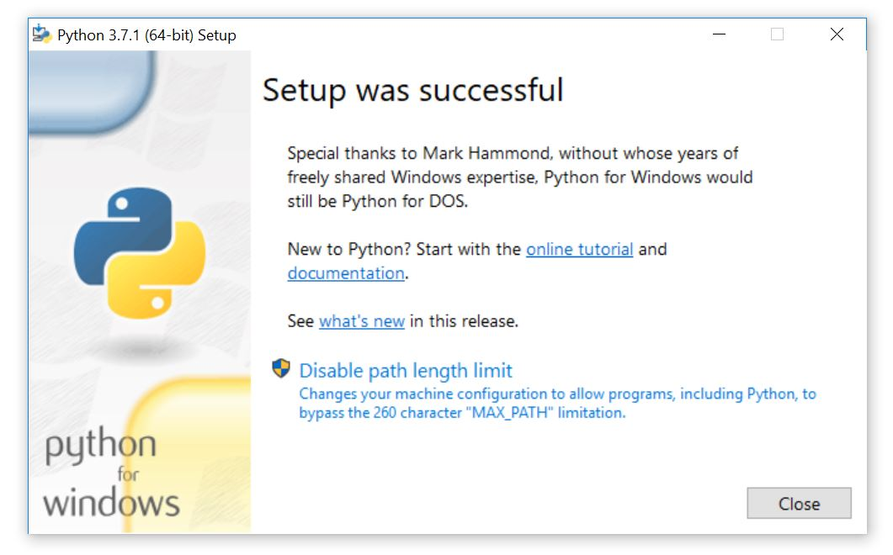

Figure 2: Disable Path length limit (optional)

* Install Pozyx and OSC Python libraries:
  + Download pozyxInstallPackages.zip, unzip and run pozyxInstallPackages.exe
    - Ignore any virus warnings
  + Google Drive link:

<https://drive.google.com/open?id=1DJPwCxmspRbBYAJbxxrxKIAEUOH08UbV>

* + NOTE: if there are problems downloading / installing packages using application, individual libraries can also be installed manually:
    - Open a “COMMAND-PROMPT” (DOS prompt) in Windows:
      * Press ‘Windows’ + ‘R’ keys
      * Enter cmd in RUN dialog
      * Press ENTER or click OK
    - At C:\> prompt, enter the following commands (individually):
    - pip install pypozyx
    - pip install python-osc
    - pip install requests
    - pip install pyserial
  + For additional information on Pozyx and application development: refer to <https://www.pozyx.io/Documentation/Tutorials/getting_started/Python>